LAB 2 : Predict Customer Churn in Camtel
Student name: Donfack Tsopfack Yves Dylane
INTRODUCTION:
The aim of this project is to build a machine learning model to predict customer churn for Camtel, a telecommunications provider, using a historical dataset that captures customer behavior over the past three years. Customer churn, or the rate at which customers leave the service, is a critical metric for companies like Camtel, as it directly impacts revenue and business sustainability.
The project is focused on training a model that can effectively predict customer churn while handling these shifts in customer behavior. We will explore and preprocess the dataset, develop initial models, and evaluate how performance changes over time. To account for concept drift and data shifts, we will apply advanced techniques such as time-weighted learning, online learning algorithms, and ensemble modeling. Our goal is to ensure that the model not only performs well on historical data but also remains adaptive and robust in the face of future changes in customer behavior. Key metrics such as accuracy, AUC-ROC, and model performance over time will be used to assess the model’s effectiveness.
Step 1: Data Cleaning, Division Between Training and Test and Handling Class Imbalance
To clean the data set I first start by loading it, then I drop any row with missing values, any duplicate rows and remove unnecessary columns like the customer_id column. All this is done by a function that I created called “import_and_clean_data”. This function make use of the pandas python package.
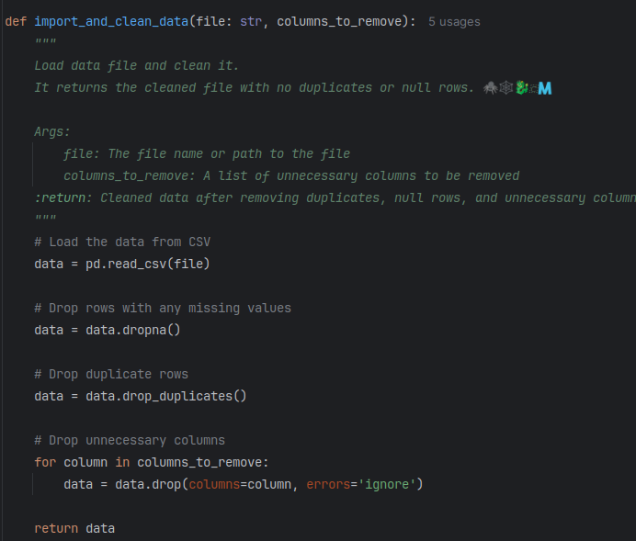Figure 1: function to import and clean the data set
Next, I converted all rows that needed to be to numerical rows, remove outlier for for every columns base base on their distribution and then split it between target an features to draw a corelation graph between features. All of this done by the functions below.
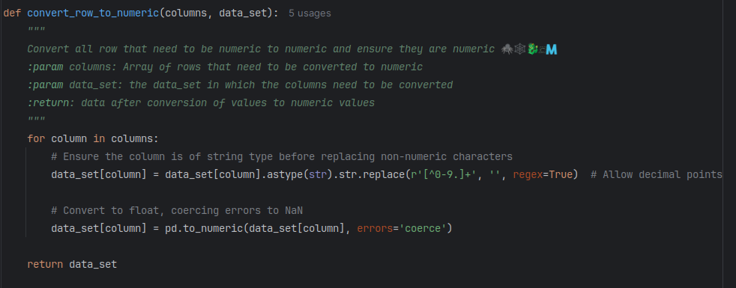Figure 2: function to convert non numerical to numerical values
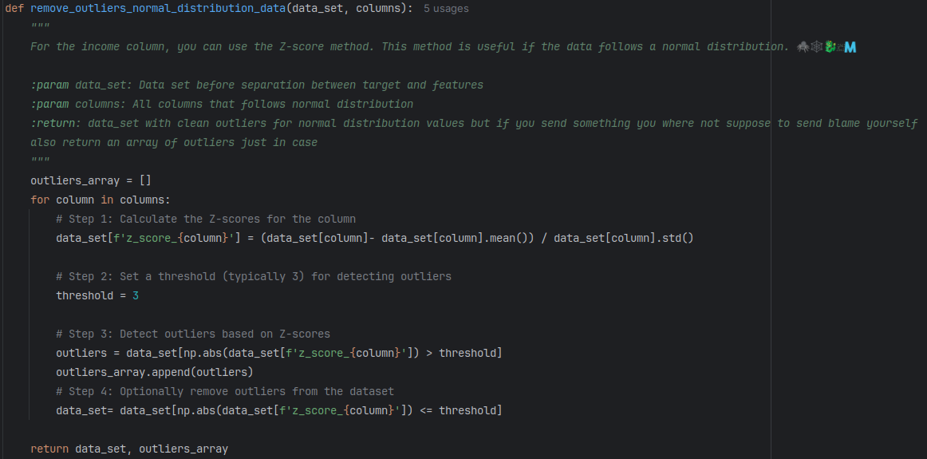Figure 3: function to remove outliers for normal distribution
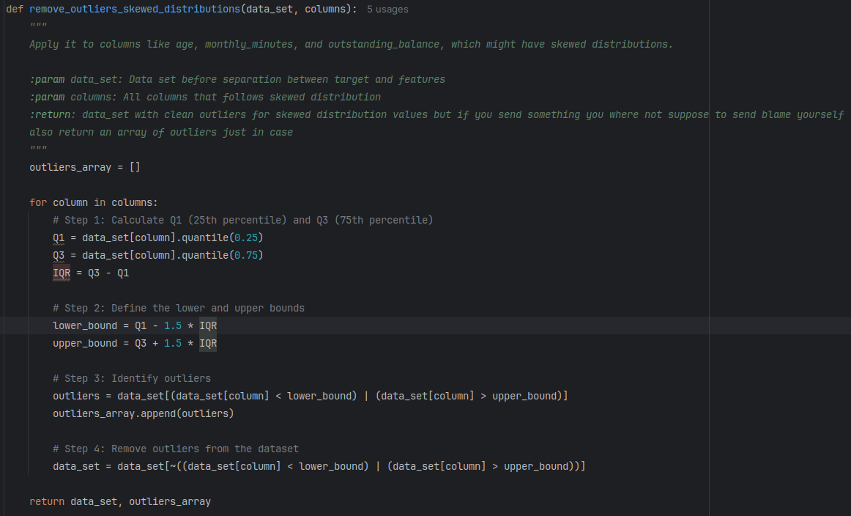Figure 4: function to remove outlier for skewed distributions
Below is the functions to obtain features and normalise their scale to produce a correlation graph of the features.
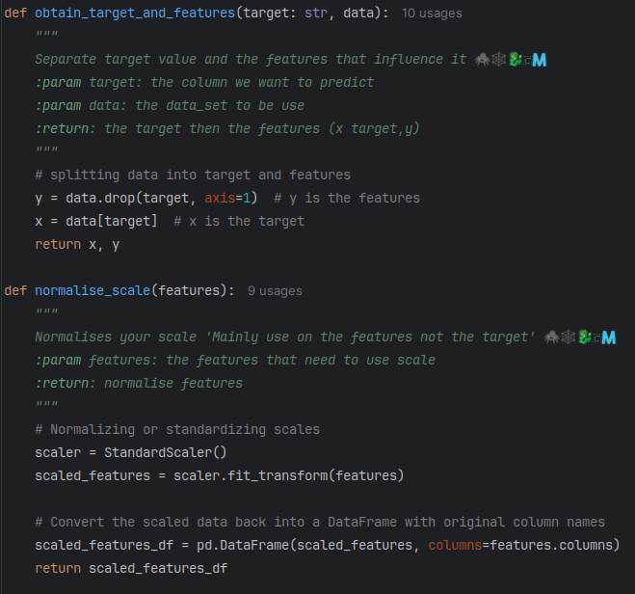Figure 5: function to obtain the feartues and function to normalise their scale

Below is the code responsible for the called of all this functions.

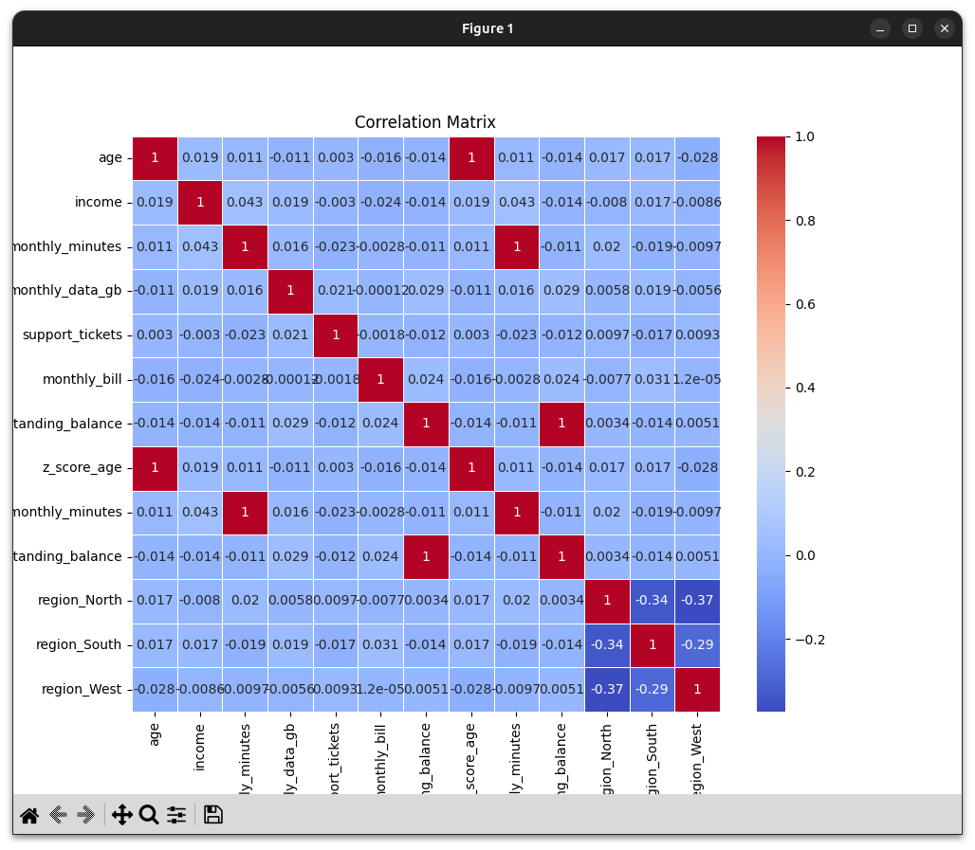Figure 6: correlation graph
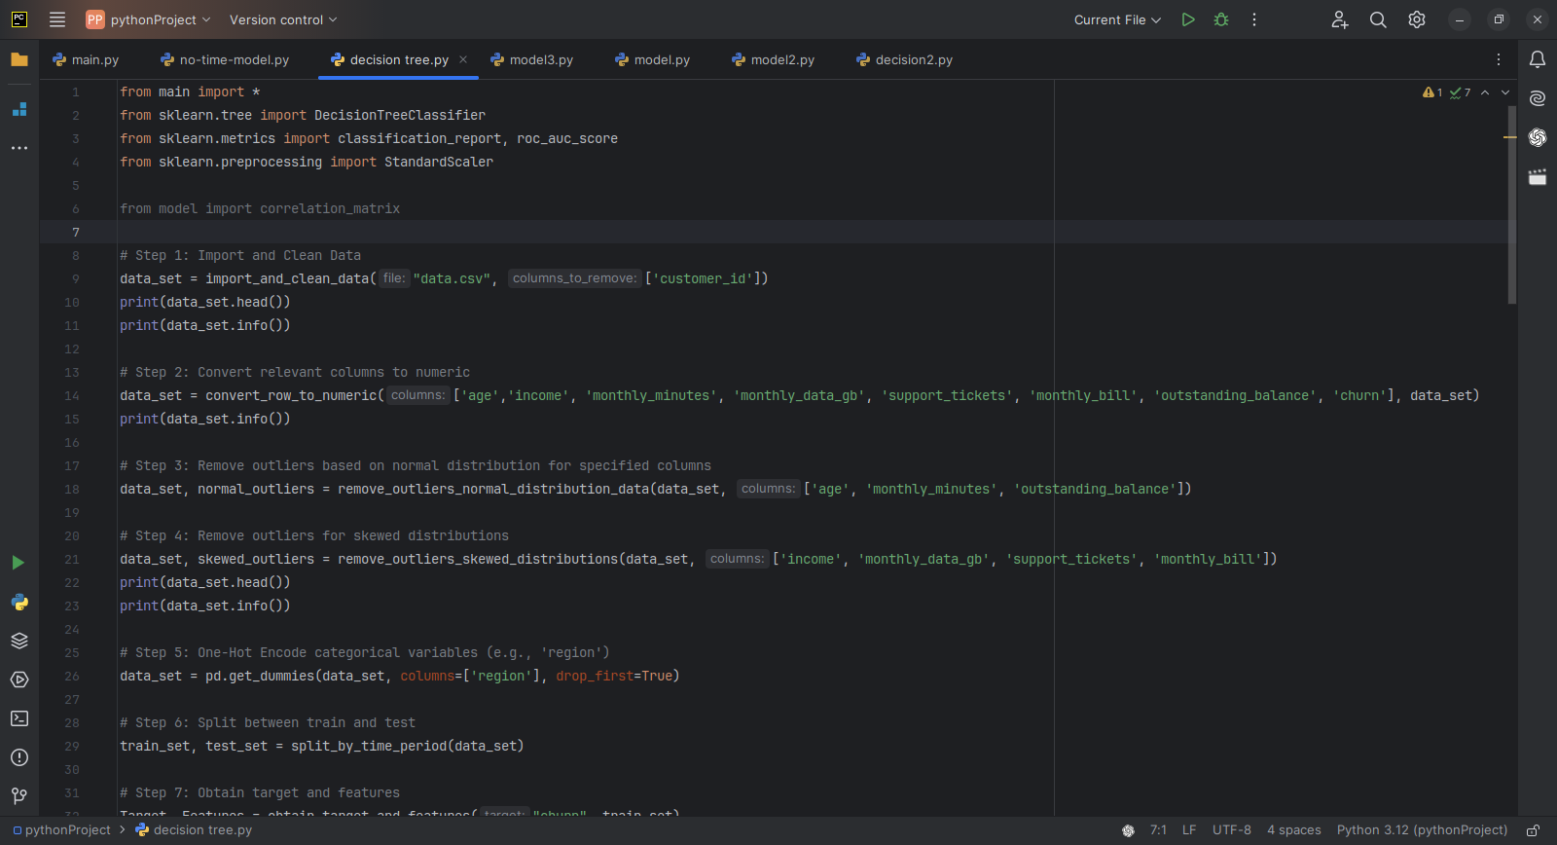Figure 7: fisrt part of the code
Step 2: Initial Model Training
For initial experiments, we chose one basic models:
- Decision Tree: A non-linear model that can capture more complex patterns in the data.

2.1 Model Training
- We trained the models using Year 1 data and tested their performance on Year 2 data.
- Model performance was evaluated using metrics such as Accuracy, Precision, Recall, F1-Score, and AUC-ROC.
- Performance Monitoring: As expected, the model performance on Year 2 data deteriorated slightly, indicating concept drift. The patterns learned from Year 1 did not perfectly translate to Year 2 due to shifts in customer behavior.

2.2 Concept Drift and Data Shift Investigation
- The model's declining performance when tested on newer data (Year 2 and Year 3) indicated the presence of concept drift.
Below is the code for training and the result obtain.
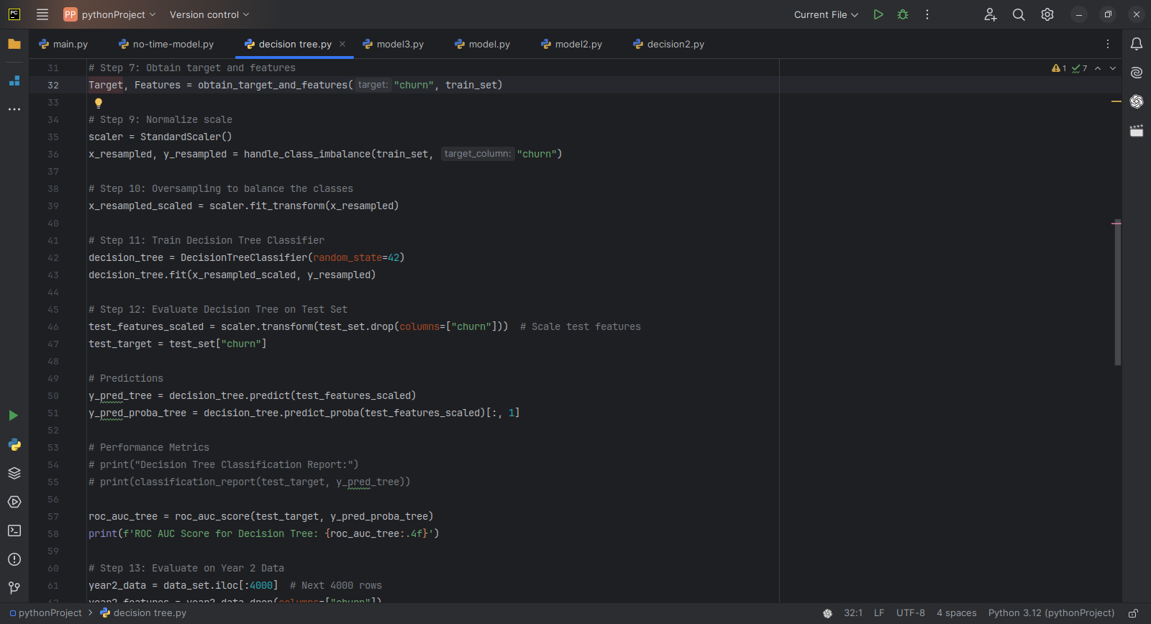Figure 8: trainig of the model
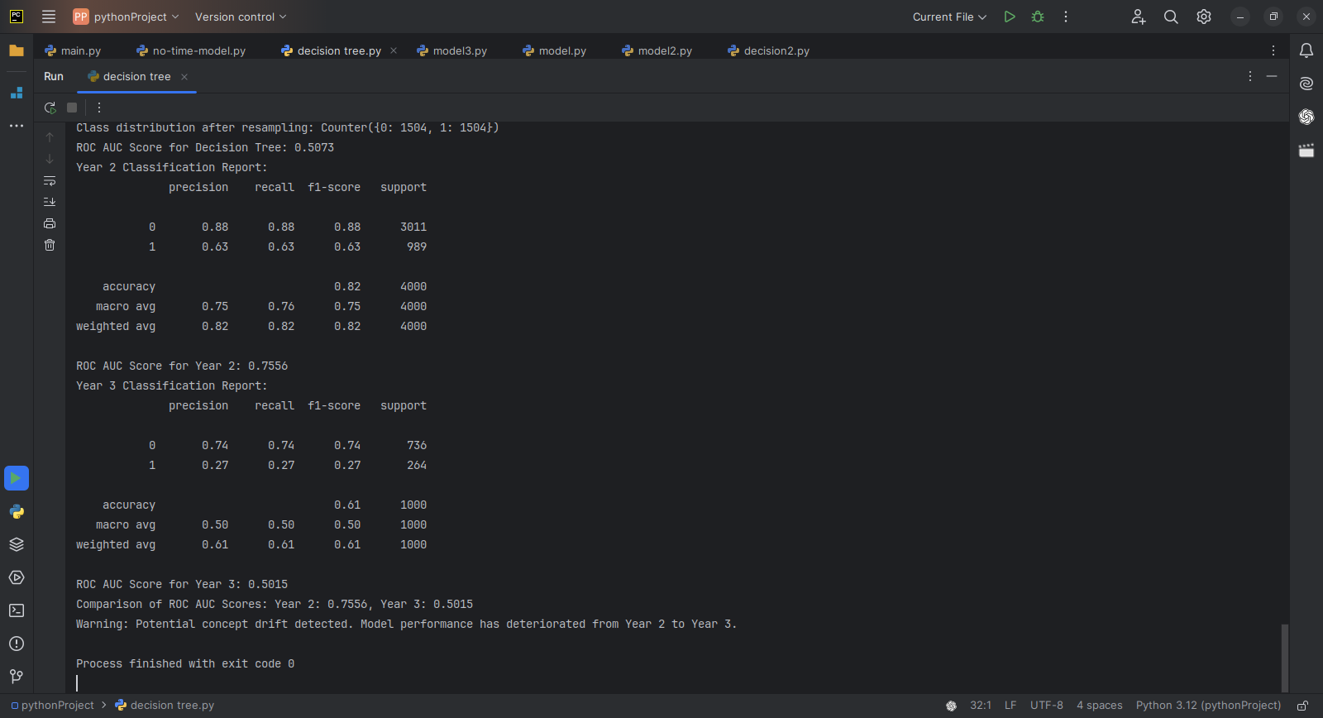Figure 9: result of the model training

Step 3: Dealing with Concept Drift and Data Shifts

3.1 Time-Weighted Learning
To address concept drift, we applied time-weighted learning, where more recent data is given higher importance during model training. This approach helps the model prioritize more relevant, up-to-date patterns.
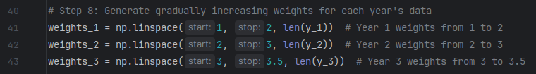Figure 10: addid weigth for each years

3.2 Online Learning with Stochastic Gradient Descent (SGD)
We also implemented an online learning algorithm using Stochastic Gradient Descent (SGD), which allows the model to be updated continuously as new data arrives. This ensures that the model adapts to changes in customer behavior in real time.
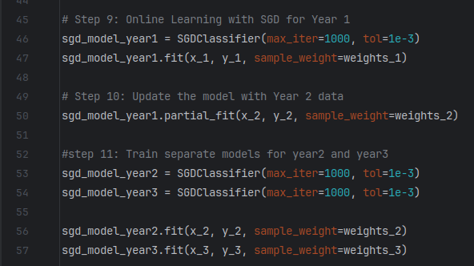Figure 11: online learning implimentation

3.3 Ensemble Models
We explored ensemble learning techniques, training separate models on each year of data and combining their predictions. This approach helps in capturing different patterns from each time period and enhances overall prediction accuracy by leveraging multiple models.

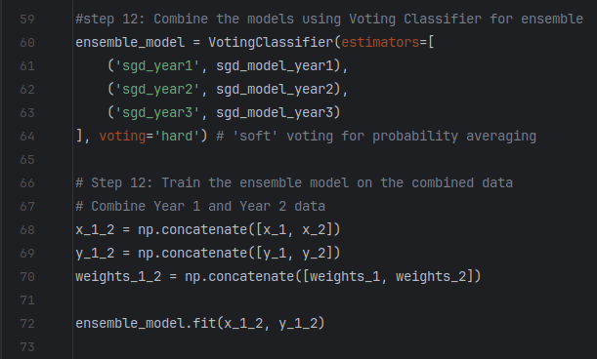Figure 12: ensemble model implementation
Below is the result of the new model.

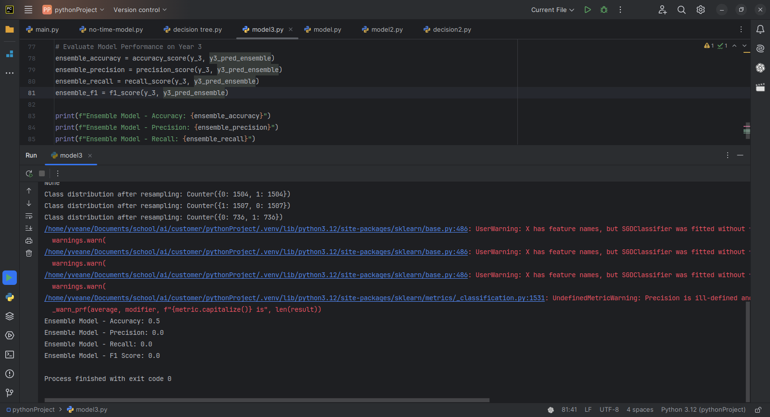

Step 4: Model Evaluation and Adaptation

4.1 Baseline vs Adapted Models
Upon comparing the performance of the baseline model with the adapted models (time-weighted learning, online learning, and ensemble models), we encountered an unexpected result. The baseline model, which does not account for concept drift or data shifts, exhibited higher precision than the adapted models, particularly in the earlier time periods.
This discrepancy suggests that the baseline model was overfitting to patterns specific to older data, which did not generalize well to newer time periods. The baseline model didn’t just show a higher precision but also a balance result for both the recall and the precision(PS: I really believe I did something wrong here).

Conclusion
In this project, we built a predictive model for customer churn at Camtel, focusing on the challenges of concept drift and data shifts. The baseline model's inability to adapt to newer data highlights the limitations of relying on historical patterns without accounting for shifting customer behaviors.
Despite attempts to address concept drift and data shifts using time-weighted learning, online learning, and ensemble methods, the adapted models did not fully resolve these challenges. This demonstrates that addressing concept drift and data shifts remains a complex issue requiring further exploration.
Moving forward, additional strategies such as advanced drift detection methods or dynamic model updates could be explored to better handle these shifts. Although concept drift and data shifts were not fully resolved, this study provides a foundation for future work in building more adaptive models for churn prediction.

